Anatomy and Physiology 12
Name:

Learning Intentions
- I know how to test if a solution is acidic or basic
- I can describe properties of acids, bases and buffers
- I can apply my understanding of acid/base balance to example in the human body
- I understand that pH regulation is essential to maintain homeostasis

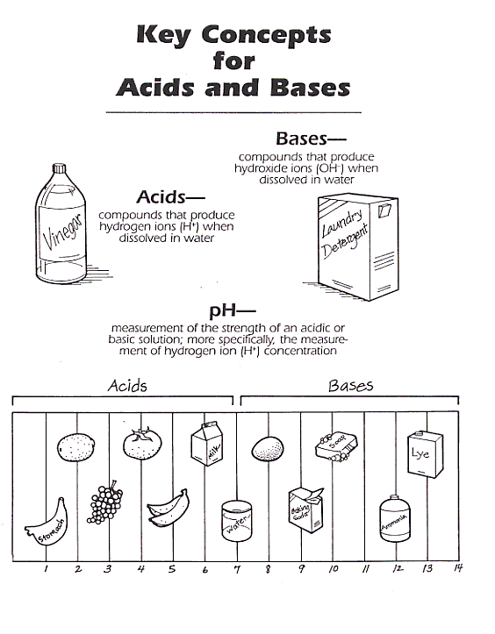
pH is a logarithmic scale. This means that each unit has 10 times the concentration of H+ of the previous unit.
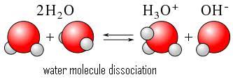

In pure water, the concentration of hydronium (H₃O⁺) ions (electrically charged atom or molecule) is very low. This means that water is neutral.

Acids – release H+ and decrease the pH of a solution
Bases – OH- or accept H+ and increase the pH
Buffer – a chemical that keeps the pH level stable

Buffers help keep pH within normal limits. In this way buffers help maintain homeostasis. For example, the pH of the blood is usually about 7.4, in part because it contains a combination of carbonic acid and bicarbonate ions.
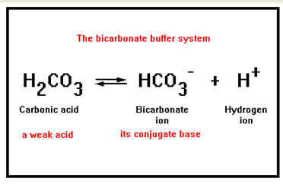

These reactions prevent any significant change in blood pH.

Discussion Questions:

- Acids/Bases are very important in biology because they help us control what chemistry occurs in our bodies. Enzymes in our digestive system work at different pH levels to help our bodies digest food in an efficient way. How is the advantage or disadvantage of controlling our enzymes function with pH instead of another aspect of our physiology such a temperature?

- If your blood became acid or basic what might happen?

