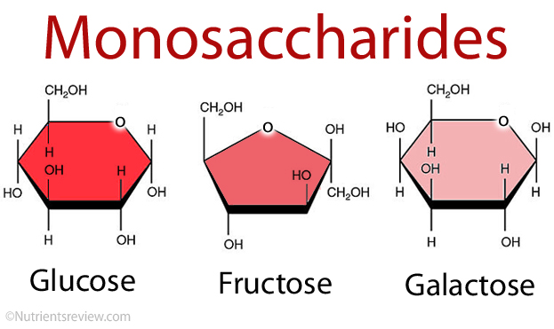

Monosaccharids are simple sugar. They are made up of only one carbon ring.

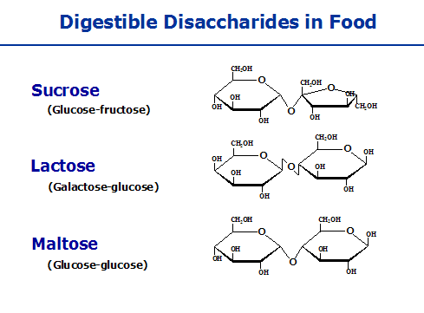

Disaccharides are made when two carbon chains form through a dehydration reaction.

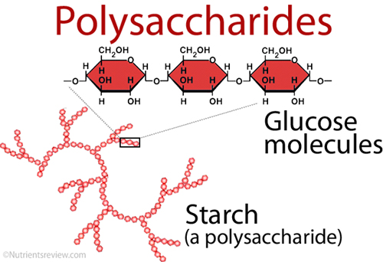

Polysaccharides are formed when many glucose monomers joint to create polymers.

