Challenge: Try This!

What would the object look like? Draw it 3D:

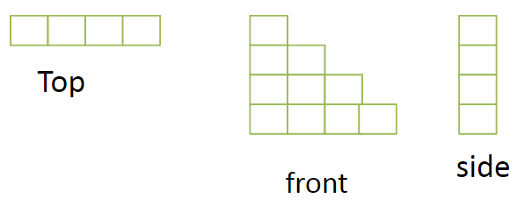

A box of markers measure 5cm by 8 cm by 2cm.  Draw a net for the box on a piece of centimeter grid paper.

