Math 8 Fractions and Word Problems
Remember these steps to guide you through the problem.
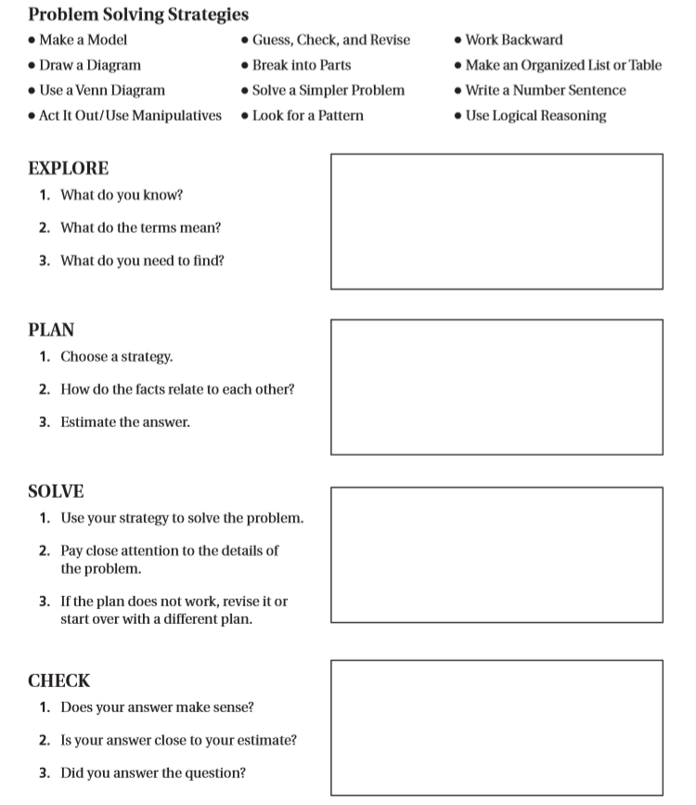
Problem 1: Neptune completes 1 ½ turns about its axis each day. How many turns does it complete in 1 week?

Problem 3: About 3/4 of the students on the track team are girls. About 3/4 of these girls are in grade 8. What fraction of the students on the track team are grade 8 girls?
Problem 2: Shane has a piece of rope that is 7 4/5 units long. If he cuts it into pieces that are each 3/5 of a unit long, how many pieces does he have?

