Math 8 Name: _______________

Linear Relation Assessment

Big Idea: Discrete linear relationships can be represented in many connected ways and used to identify and make generalizations.

Content:
Linear relations
- Two-variable Linear relations
- Expressions, Table of Values, and Graphs
- Scale Values (e.g., tick marks on axis represent 5 units instead of 1)
- Four quadrants, Integral Coordinates

Expressions
- using an expression to describe a relationship
- evaluating 0.5n – 3n + 25, if n = 14

Curricular Competencies:

Reasoning and Analyzing: Demonstrate and apply mental math strategies.

Understanding and Solving: Visualize to explore mathematical concepts.

Tools Used to Complete Assessment. Check all that apply.

Multiplication Chart
Calculator
Translator
Teacher/ EA Support – circle questions student requires support with
Other ________________________

Assessment
Exemplary | Accomplished | Developing | Beginning
I can apply my knowledge of this skill to complete problems.  Ex: word problems | I can solve problems when all information is provided.  Ex: 2 step math problems | I can calculate when I am provided the steps to complete problems.  Ex: steps are provided for me | I am still working towards the correct steps necessary to complete problems.

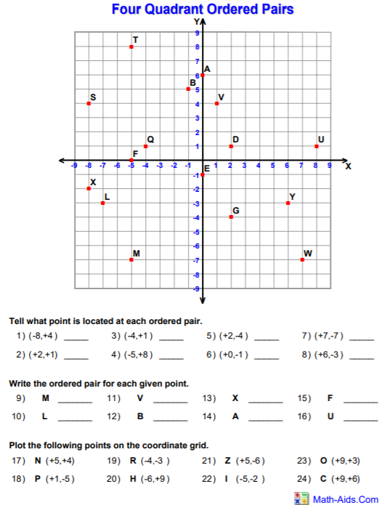

Analyzing Graphs of Linear Relations

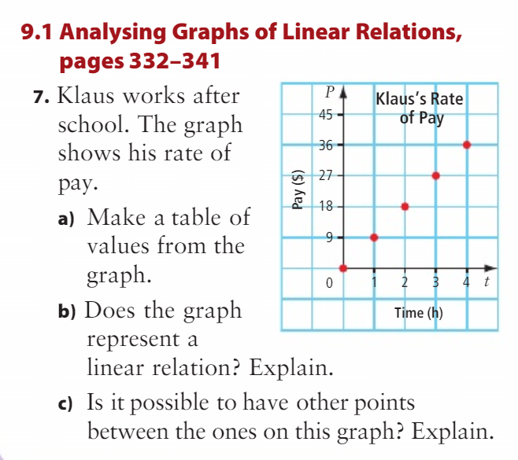

Speedy print shop charges $2 for the first colour copy and $ 1 for each additional colour copy.

  - Make a table of values representing the number of colour copies in relation to the cost. Include zero to five colour copies.
  - Is this a linear relation? Explain.
  - What is an expression for the cost in terms of the number of colour copies?
  - What is the cost of 12 colour copies?

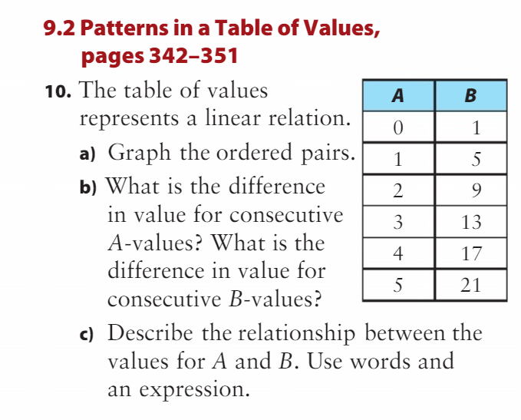

For each equation determine the values for y when x = -7. Use substitution (replacing “x” with “-7” and solving for y.

Y = 7x

Y = 3x -2

Y = -2x + 3

