Steroids- All steroids are hydrophobic molecules derived from a common 4 fused carbon ring structure
- Cholesterol which helps stiffen the membrane
- Cholesterol is an important part of the plasma membrane that surrounds animal cells
- Sex hormones control the development of sexual traits and sex cells that are specific to males and females
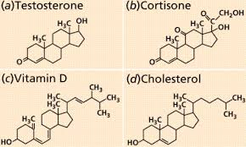

Phospholipids- Each phospholipid is made up of two fatty acids, a phosphate group, and a glycerol molecule.
- Phospholipids are able to form cell membranes because the phosphate group head is hydrophilic while the fatty acid tails are hydrophobic
- Function: Form basis of cellular membranes; a membrane that surrounds a cell is made up of proteins and lipids.
