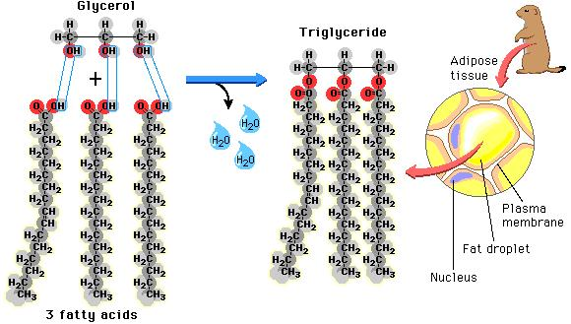

Triglycerides: Has a 3-part structure; Formed when one glycerol molecule reacts with three fatty acid molecules

- Primary function is fat storage
- Oils are liquids at room temperature
- Insulate against heat loss
- Forms a protective cushion around major organs
- Has a 3-part structure; Formed when one glycerol molecule reacts with three fatty acid molecules
- Organized into 2 subgroups: saturated and unsaturated fat. 