Inquiry-Based Learning

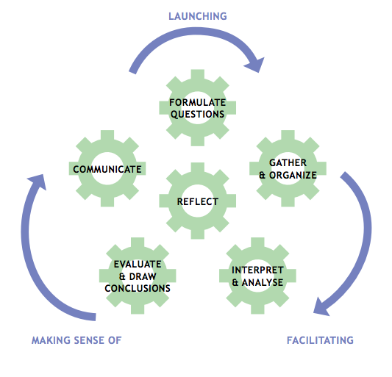
Have you ever wondered, how your body turns the food you eat into fuel? How does your body get fuel to pump your heart, power your brain and provide you energy to do daily activities? Think about your own experiences. What do you feel like when you have not had enough to eat in a day? What do you feel like when you only eat cookies for lunch compared to a balance meal? This project is designed to get you thinking about how your body uses the fuel that you provide it and what fuel is ideal for healthy body functions.

Formulate A Question: This assignment is a guided inquiry, meaning that you are provided a question to investigate. Later A&P12 you will have the opportunity to formulate your own question to investigate through inquiry.

How does your body metabolize and store the food you eat in one day?

Gather and Organize: To gather data about the food you eat in one day, you will keep a food journal. In addition, you will record the number of grams of carbohydrates (fiber and sugar), lipids (fats) including saturated, non-saturated, and trans fats, and protein in a data table.

Interpret and Analyze: Once you have recorded your data indicating the number of grams of fiber, sugar, saturated fat, non-saturated fat, trans fat, and protein you ingested in one day, you will compare these results to the recommended health guidelines. See recommendations here: http://thescienceofeating.com/food-combining-how-it-works/calories-fat-carbs-protein-per-day/ (link is provided on website). Based on this comparison you will interpret what your results mean. To demonstrate your findings complete a bar graph including the recommended grams of food compared to what you ate in one day. Analyze the trends of your data and identify any inconsistences.

Evaluate and Draw Conclusions: Based on your results what conclusion can you make? Evaluate the quality of the food that you ate? Did you provide your body with sufficient fuel? Use the knowledge that you learned while discussing metabolism in class and watching the Ted Talk video to draw conclusions that are consistent with your data. Suggest what kind of improvements you could make to your diet to ensure your body is getting the right fuel.

Communicate: Explain how your body maintains balance blood sugar levels based on the V.O.D and metabolism notes. Be sure to include carbohydrates, proteins, lipids, and ketones. Include a diagram to enhance your answer.

Curricular Competencies | Developing | Accomplished | Exemplary
Processing and Analyzing Data and Information
- Seek and analyze patterns, trends, and connections in data, including describing relationship between variables, performing calculating’s, and identifying inconsistencies
- Use knowledge of scientific concepts to draw conclusions that are consistent with evidence
Evaluating
- Evaluate their methods and experimental conditions, including identifying sources of error or uncertainty, confounding variables, and possible alternative explanations and conclusions
- Describe specific ways to improve their investigation methods and the quality of the data
Communicating
- Communicate scientific ideas, information, and perhaps a suggested course of action, for a specific purpose and audience, constructing evidence-based arguments and using appropriate scientific language, conventions, and representations

